Perth Modern School

Semester Two Examination, 2019

Question/Answer Booklet

MATHEMATICS
METHODS
UNIT 3 & 4

Section Two:

Calculator-assumed

Your name

Your Teacher’s name

Time allowed for this section
Reading time before commencing work: ten minutes
Working time for section: one hundred minutes

Materials required/recommended for this section
To be provided by the supervisor
This Question/Answer Booklet
Formula Sheet (retained from Section One)

To be provided by the candidate
Standard items: pens (blue/black preferred), pencils (including coloured), sharpener, correction fluid/tape, eraser, ruler, highlighters

Special items: drawing instruments, templates, notes on two unfolded sheets of A4 paper, and up to three calculators approved for use in the WACE examinations

Important note to candidates
No other items may be taken into the examination room. It is your responsibility to ensure that you do not have any unauthorised notes or other items of a non-personal nature in the examination room. If you have any unauthorised material with you, hand it to the supervisor before reading any further.

Structure of this paper

Section | Number of questions available | Number of questions to be answered | Working  time (minutes) | Marks available | Percentage of exam
Section One:  Calculator-free | 7 | 7 | 50 | 50 | 35
Section Two:  Calculator-assumed | 14 | 14 | 100 | 105 | 65
 |  |  | Total | 155 | 100

Instructions to candidates

- The rules for the conduct of examinations are detailed in the school handbook. Sitting this examination implies that you agree to abide by these rules.

- Write your answers in this Question/Answer Booklet.

- You must be careful to confine your response to the specific question asked and to follow any instructions that are specified to a particular question.

- Spare pages are included at the end of this booklet. They can be used for planning your responses and/or as additional space if required to continue an answer.
- Planning: If you use the spare pages for planning, indicate this clearly at the top of the page.
- Continuing an answer: If you need to use the space to continue an answer, indicate in the original answer space where the answer is continued, i.e. give the page number. Fill in the number of the question that you are continuing to answer at the top of the page.

- Show all your working clearly. Your working should be in sufficient detail to allow your answers to be checked readily and for marks to be awarded for reasoning. Incorrect answers given without supporting reasoning cannot be allocated any marks. For any question or part question worth more than two marks, valid working or justification is required to receive full marks. If you repeat any question, ensure that you cancel the answer you do not wish to have marked.

- It is recommended that you do not use pencil, except in diagrams.

- The Formula Sheet is not to be handed in with your Question/Answer Booklet.

Section Two: Calculator-assumed (105 Marks)
This section has thirteen (13) questions. Answer all questions. Write your answers in the spaces provided.

Working time for this section is 100 minutes.

Question 8 (4 marks)
The area of a triangle can be found by the formula $Area=\frac{1}{2} ab\sin{C}$. Using the incremental formula, determine the approximate change in area of an equilateral triangle, with each side of 5 cm, when each side increases by 0.2 cm.

Solution
Specific behaviours
obtains expression for area in terms of side length
uses incremental theorem
differentiates correctly
determines approx. change in area (no need for units)

Question 9 (9 marks)

- The probability of Australian Year 12 students obtaining their driver’s licence is thought to be around 65%. How large a sample of students should be used to establish this within a margin of error of 5% at the 90% confidence level? (3 marks)

Solution
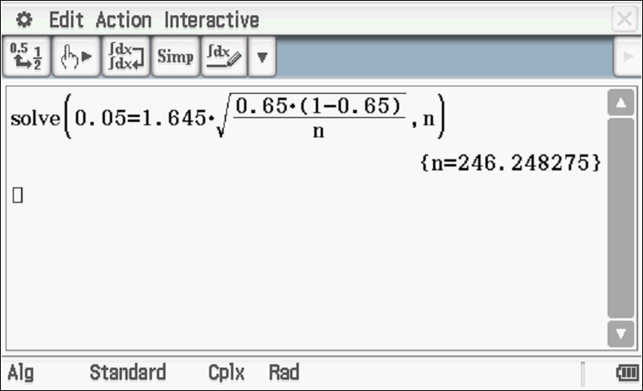
n=247

Specific behaviours
uses z percentile for 0.90
states an equation for sample size
rounds n up

- A survey of 1000 Australians renting houses found that 35% of their income was paid in rent.

- Estimate the standard deviation of the sampling distribution. (2 marks)
Solution
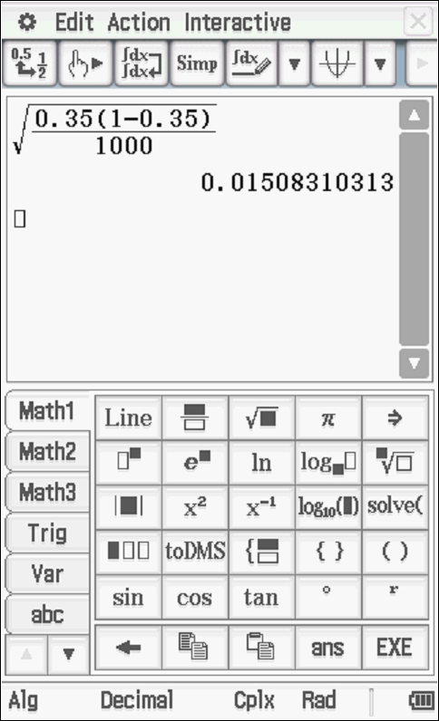

Specific behaviours
uses formula
states standard deviation

- What z-score should be used for an 80% confidence interval? (1 marks)

Solution
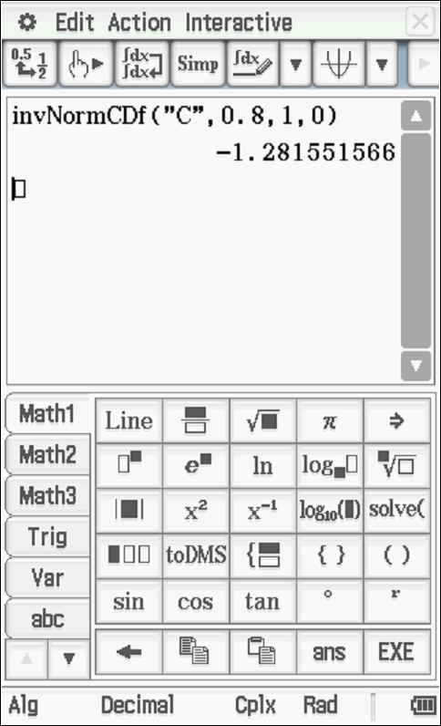

Z score 1.282
Specific behaviours
states z score

- Estimate the 80% confidence interval for the proportion of income used for renting in Australia. (3 marks)
Solution
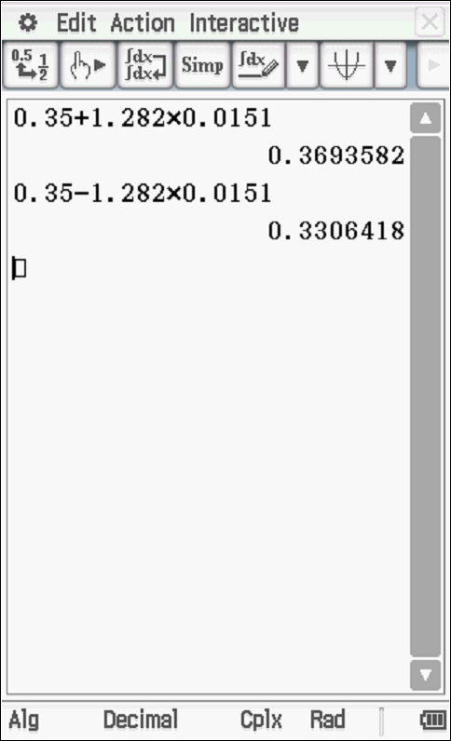

Specific behaviours
multiplies z score by standard deviation
shows calculation for one endpoint
states other endpoint (ignore number of dp)
NOTE: max of 2 marks for interval only

Question 10 (6 marks)

Let .
- Determine using the quotient rule. (3 marks)

Solution
Specific behaviours
uses quotient rule
diff ln correctly
states an un-simplified expression

- Sketch on the axes below showing any intercepts and asymptotes. (3 marks)

Solution
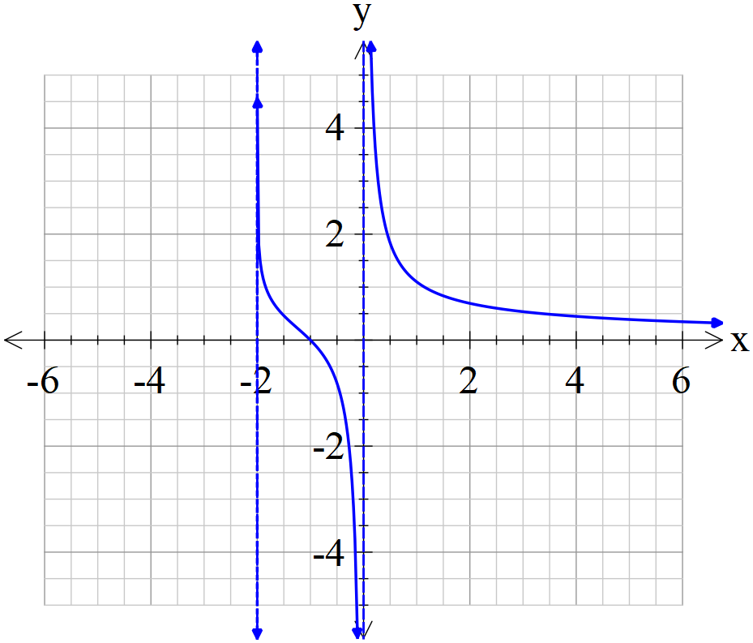

Specific behaviours
shows two asymptotes
shows x intercept
correct shape shown only for x>-2

Question 11 (9 marks)
In a general population, 15% of people are left-handed. A class has 32 students and number of who are left-handed is counted. Let = number of left-handed students in a class of 32 students.

- State and describe the type of distribution of. (3 marks)
Solution
Specific behaviours
states Binomial
states n value
states p value

- How many in the class would you expected to be left-handed? (1 mark)
Solution
Specific behaviours
states mean value

- What is the probability that the number of left-handed students in the class is within one standard deviation of the mean? (3 marks)
Solution
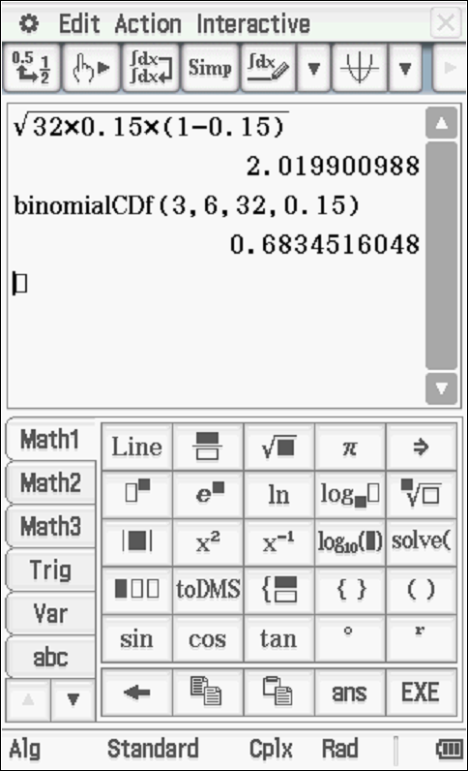

Specific behaviours
calculates standard deviation
states appropriate integer endpoints within one standard deviation
states probability

- Find the probability that at most half of the class are left-handed. (2 marks)

Solution
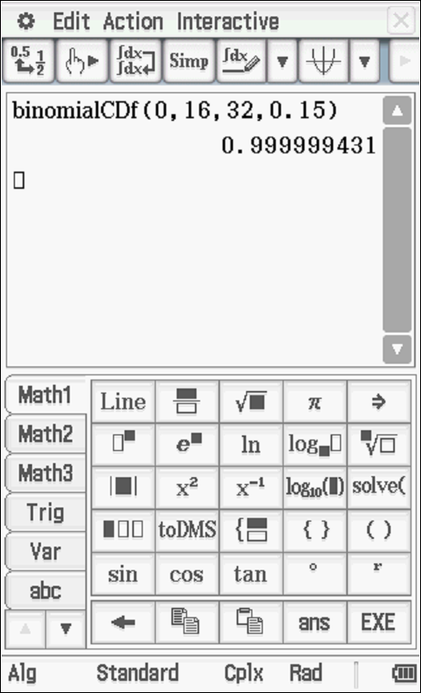

Specific behaviours
uses correct limits
states probability(accept 1.0)

Question 12 (6 marks)
The equation is used to measure the acceleration, metres per second squared at time seconds, of a weight at the end of a spring. Initially the weight is at rest at the origin.

- Find the velocity of the weight after $\frac{π}{4}$ seconds. (3 marks)

Solution
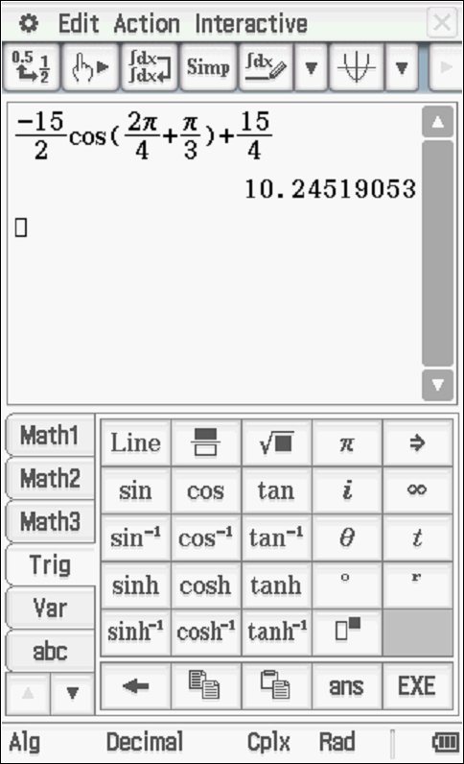

Specific behaviours
integrates sine term
solves for constant
determines velocity(no need for units)

- Find its displacement from the origin after $\frac{π}{2}$seconds. (3 marks)
Solution

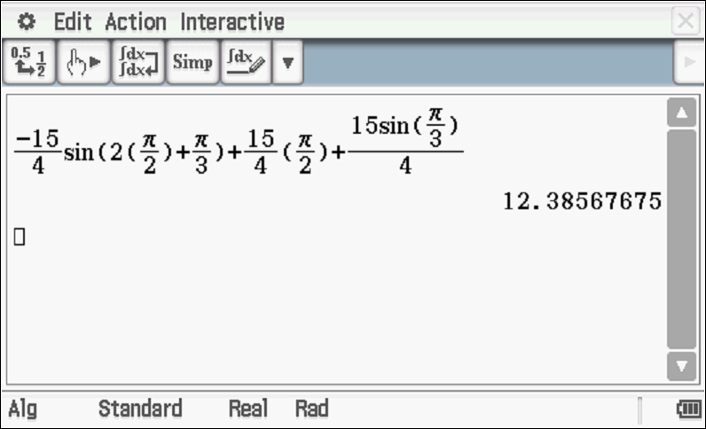
Specific behaviours
integrates cosine term
solves for constant
determines displacement (no need for units) NOTE: follow through from (a)above

Question 13 (9 marks)

A chocolate factory makes bars of chocolate such that the mass of these bars forms a normal distribution of mean mass of 35 grams and a standard deviation of 4 grams. Only those bars that have a mass within 1.5 standard deviations are usually sent to stores for sale.
- Determine the probability that a bar of chocolate produced, will be usually sent to a store for sale. (3 marks)
Solution
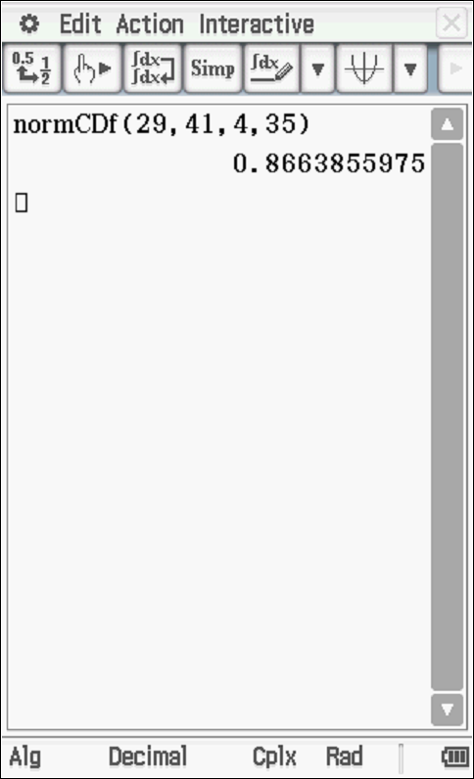

Specific behaviours
states lower limit
states upper limit
determines probability
Note: 2 marks for answer only

In December each year, the person who’s job is to check the mass of bars is on holiday and no one replaces their role. The bars of chocolate are packed in boxes of 50.
Let = number of bars suitable for sale in a box of 50 in December.
- State the distribution for giving the mean and standard deviation. (3 marks)
Solution
Specific behaviours
states binomial
states mean
states standard deviation

- Determine the probability that in a given box of 50 that at least 40 are suitable for sale in December. (2 marks)
Solution
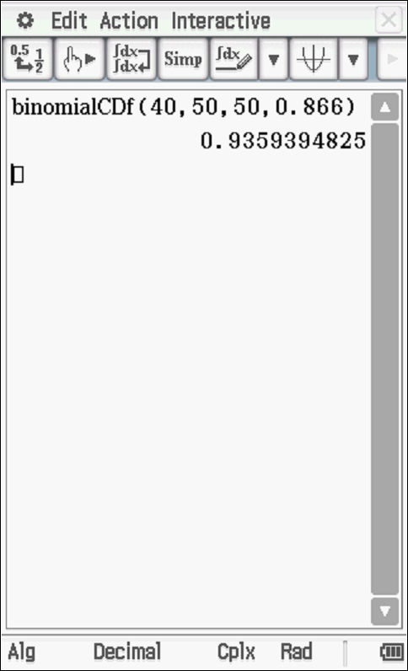

Specific behaviours
uses correct parameters
states probability

- It is decided to employ a part time worker in December to select boxes of 50 at random to check the number of bars that are suitable for sale. State a method for randomly selecting these boxes for inspection. (1 mark)

Solution
Use a random number generator for selecting which order of boxes will be examined.

Specific behaviours
reasonable random method of selecting boxes.
(Do not accept every third box etc as not random)

Question 14 (8 marks)
For the following questions, show using calculus how to determine an optimal solution.

- Determine two positive numbers, $x$ and $y,$ whose product is 36 and such that $2x+y$ is a minimum.
(4 marks)

Solution
Specific behaviours
obtains expression in terms of one variable only
differentiates
equates to zero and solves for exact value of one variable (no need to simplify)
solves for other variable

- Find the area of the largest rectangle of lengths that can be enclosed in a circle of radius $r.$
(4 marks)

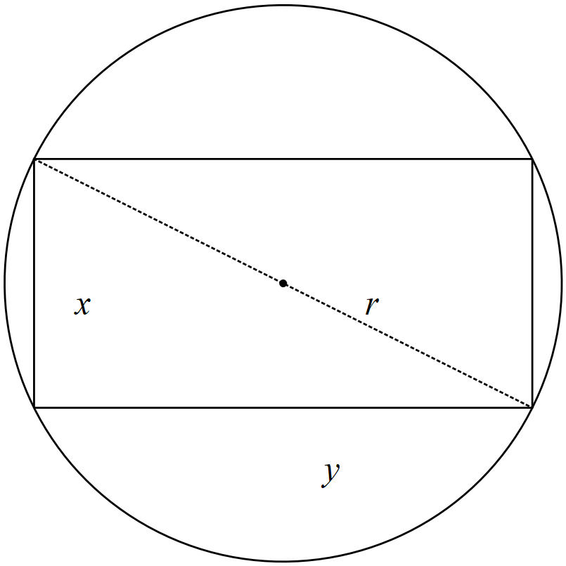

Solution
Specific behaviours
obtains y in terms of x and r (or vice-versa)
differentiates area using the product rule
equates to zero and solves for x in terms of r
determines other variable in terms of r and states area in terms of r.

Question 15 (8 marks)

A game consists of a wheel divided into sixteen equal sectors numbered 1 through 16. You may place a $2 bet on any number. If your number comes up, you get $20 back. That is, you win $18 after getting your $2 back. If you lose then you have lost $2.

- Let $X$ be the amount of profit won on a bet by the player. Find the amount the player expects to profit on a bet. i.e , explain what this means. (3 marks)

Solution
$$x$$ | $18 | -$2
$$P(x)$$ | 1/16 | 15/16
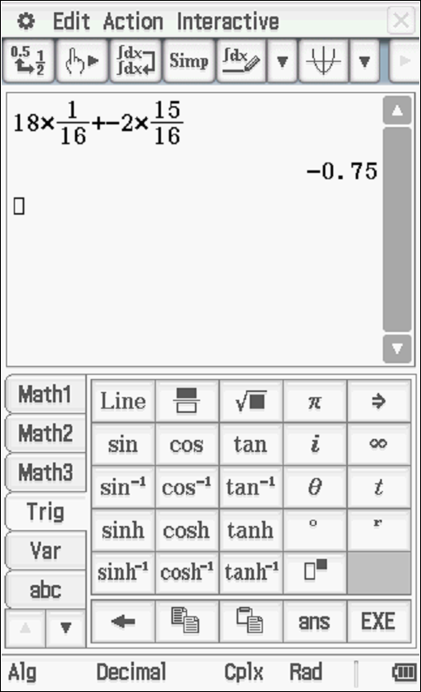

Specific behaviours
shows calculation of mean
states mean
explains that the player expects to lose on a play

- Determine the standard deviation of , amount of profit won on a bet by the player (3 marks)

Solution
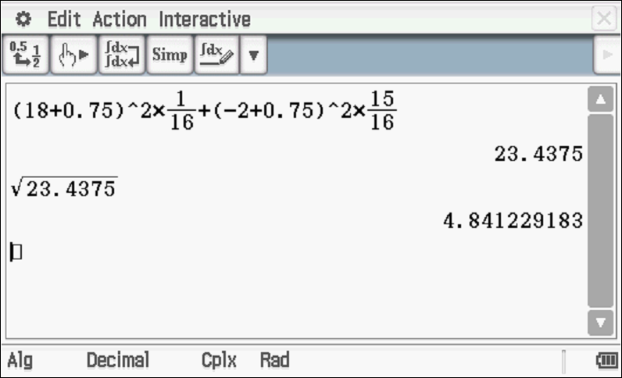

Specific behaviours
shows calculation
determines variance(uses square root in calculation)
determines standard deviation

- How much should you win for the game to be fair? ($E(x)=0$) (2 marks)

Solution
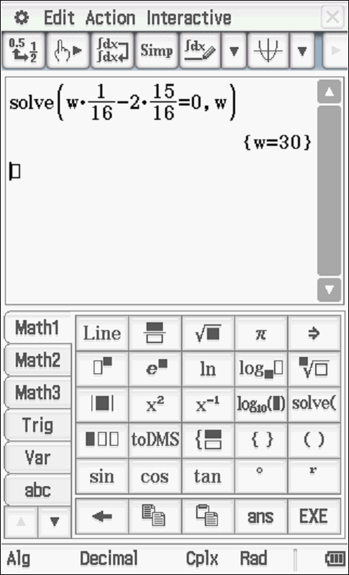

WIN $30 i.e profit of $30 Or you get back $32
Specific behaviours
sets up equation for profit on win
states winning profit or cash back

Question 16 (8 marks)
The displacement, , in centimetres of a particle from the point O in a straight line is given by
$x\left(t\right)=\frac{1}{2}{\left(\frac{t}{3}-4\right)}^{2}-2$ for $0≤t≤12$, where $t$ is measured in seconds.

Calculate the:

- Time(s) that the particle is at rest. (2 marks)

Solution
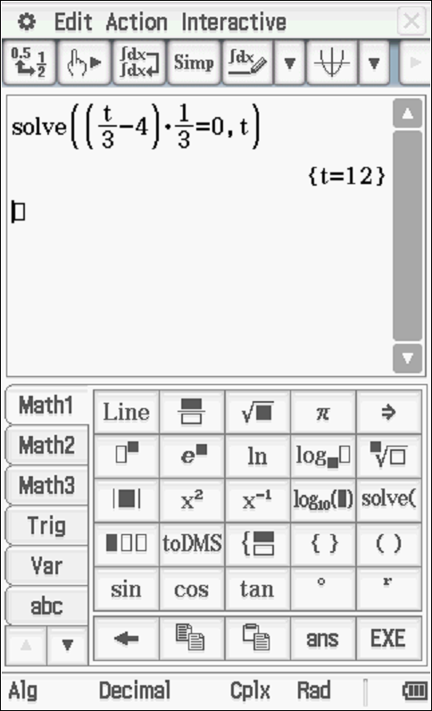

Specific behaviours
differentiates
solves for t (no need for units)

- Displacement of the particle during the sixth second. (2 marks)

Solution
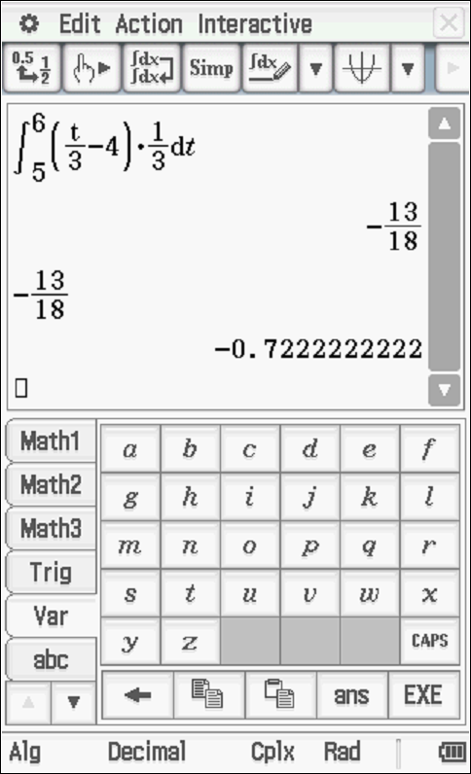

Specific behaviours
integrates velocity over sixth second or uses displacement for 5 & 6 sec
determines displacement

- Maximum speed of the particle and the time when this occurs. (2 marks)

Solution
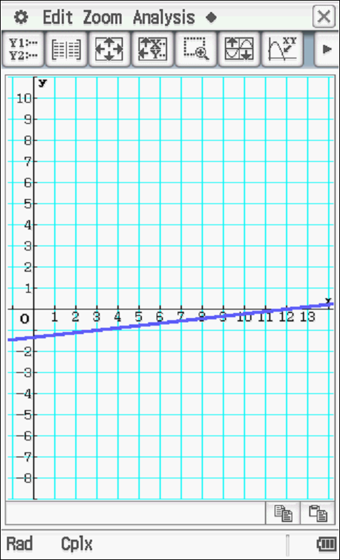

Initial speed of 4/3 m/3

Specific behaviours
examines first 12 secs only
states initial speed of 4/3 (no need for units) must be positive

- Total distance travelled in the first 12 seconds. (2 marks)

Solution
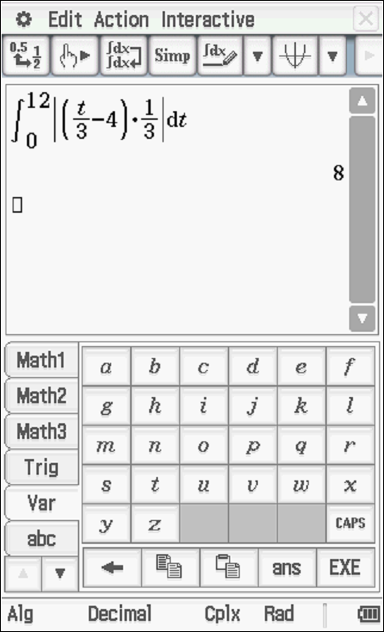

Specific behaviours
uses appropriate integral or number line diagram
states distance of 8 metres (no need for units)

Question 17 (7 marks)
A school has analysed the exam scores for all Year 12 Methods students and found that the mean was 76 with a standard deviation of 21. Let $X$ be the exam scores out of a 100. Determine the following.

- $E(X-6)$ (1 mark)

Solution
Specific behaviours
states new expected value

- $Var (10-2X)$ (2 marks)

Solution
Specific behaviours
squares standard deviation
multiplies by positive four only.

The school has decided to scale the results down to mean of 65 and standard deviation of 15, using the transformation $Y=aX+b$ where $a$and $b$ are constants and $Y$ is the scaled percentage scores.

(c) Determine the value(s) of $a$ and $b$. (4 marks)

Solution
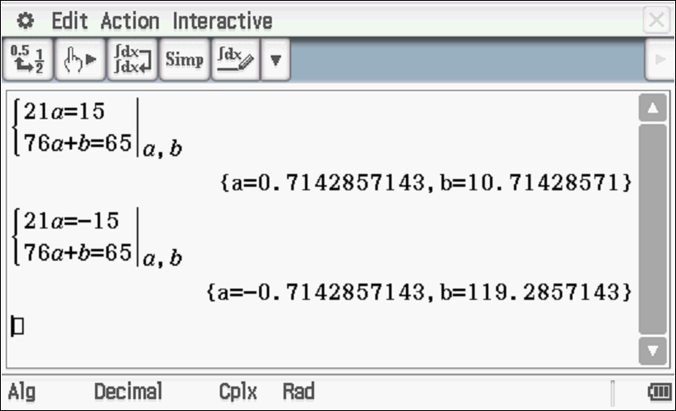

Specific behaviours
sets up one equation for a only
sets up second equation with a and b
solves for one pair of values
solves for second pair of values
Max of 3 out of 4 marks if multiplying by a is not first

Question 18 (10 marks)
A government agency is investigating the number of motor vehicles in Perth that are producing an illegal amount of pollution. In a sample of 350 motor vehicles, 35 where found to produce an illegal amount of pollution.

- Calculate the sample proportion of vehicles that are illegally polluting. (1 mark)

Solution
Specific behaviours
states proportion

- Determine an 85% confidence interval of the true proportion of vehicles illegally polluting to four decimal places and state the margin of error, (4 marks)

Solution
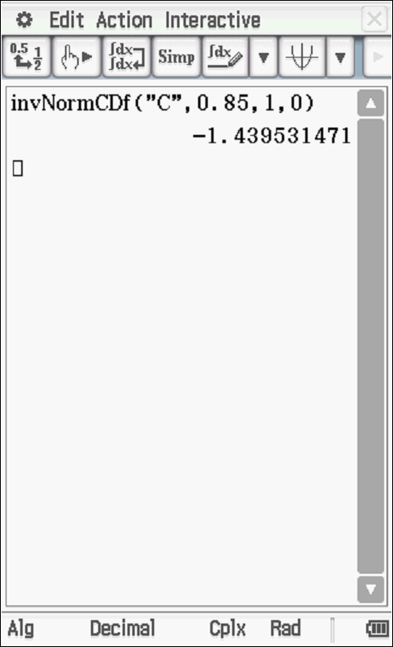

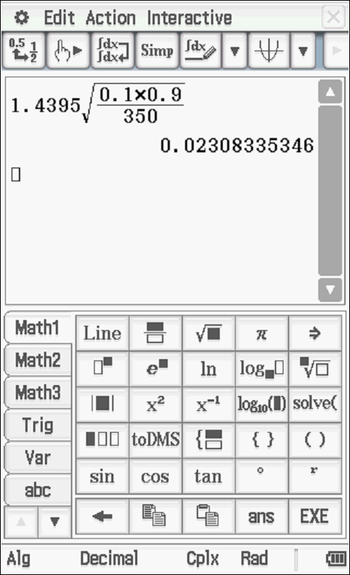
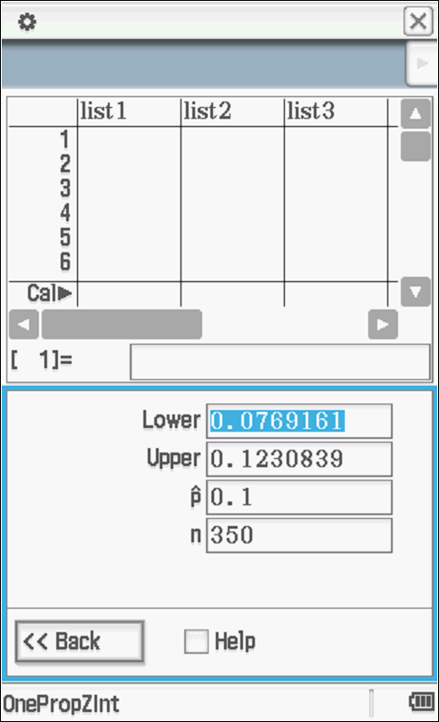

0.0769- 0.1231
Margin of error =0.0231
Specific behaviours
states z percentile
determines confidence interval
determines margin of error
rounds to 4 dp

- Determine the probability that in a random sample of 350 vehicles, the proportion of polluting vehicles lies between 0.08 and 0.12. (2 marks)

Solution
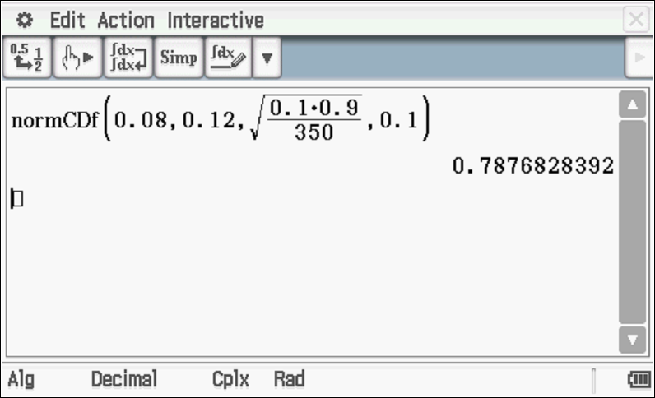

Specific behaviours
uses normal with correct parameters
states probability ( no need to give 4 dp)

- Below are three samples of vehicles, one of them is actually from another country. Which one is most likely not to be in Perth and give reasons. (3 marks)
(Continue with a confidence of 85%)

Sample A  44 polluting vehicles out of a sample size of 340 | Sample B  20 polluting vehicles out of a sample size of 280 | Sample C  50 polluting vehicles out of a sample size of 420

Solution
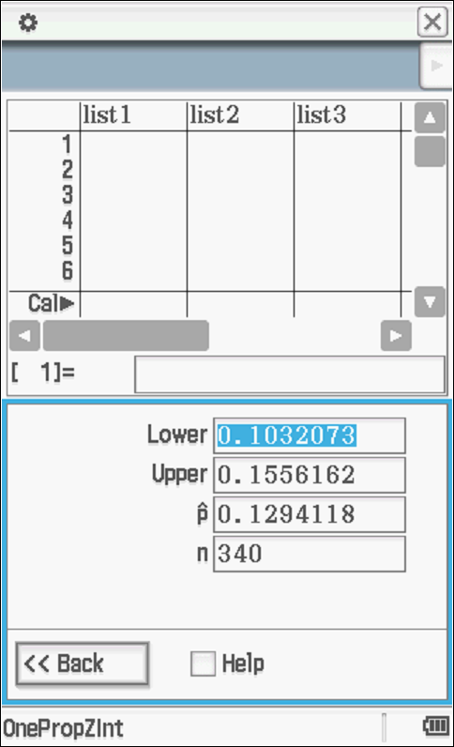 | 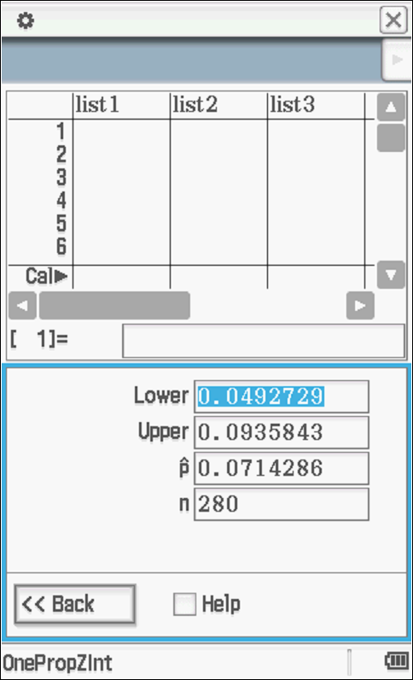 | 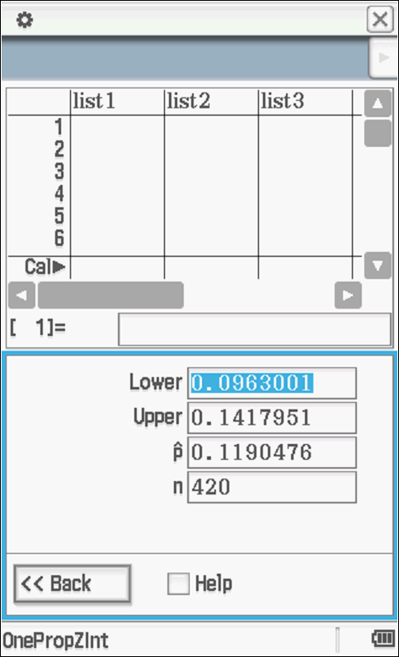

Sample B’ confidence interval does not overlap with the other two, therefore most likely.

OR
Not all intervals contain true value of p therefore unable to tell.

Specific behaviours
gives two confidence intervals
gives three confidence intervals
gives an explanation which mentions confidence intervals

Question 19 (6 marks)
The diagram below shows the graph of $y=(x+1)(x-1)(x-d)$ with constant $d$ where $d>1.$ The graph intercepts the y-axis at the point A.

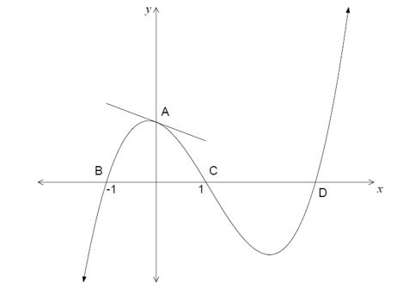
$$(d,0)$$

- Find the equation of line $AD$ in terms of $d$. (2 marks)

Solution
Specific behaviours
determines gradient
determines equation

- Show that a line that passes through $A$ and $D$ is tangent to the graph at $A$. (4 marks)

Solution
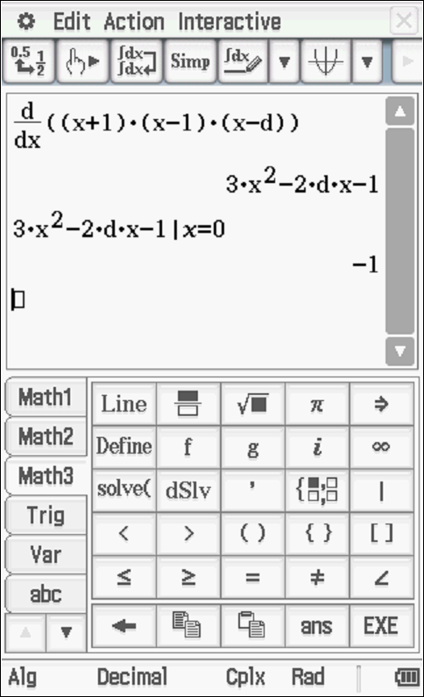

As both line and curve have a common point A at x=0 and same gradient at this point then line is a tangent

Specific behaviours
differentiates curve
determines derivative at x=0
states common point A
states gradients both -1 at pt A

Question 20 (10 marks)
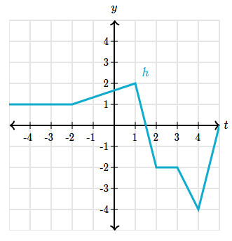
The graph of $h(x)$ is shown on the right.

- Evaluate the following definite integrals
- $\int_{-2}^{1}{h^{'}\left(x\right) dx}$ (2 marks)

Solution
Specific behaviours
uses fundamental theorem
determines integral

- $\int_{2}^{3}{10h^{'}\left(x\right) dx}$ (2 marks)

Solution
Specific behaviours
uses fundamental theorem with factor 10
determines integral

- $\int_{-2}^{4}{{(h}^{'}\left(x\right)+1) dx}$ (2 marks)

Solution
Specific behaviours
integrates both terms correctly
uses limits to determine integral

- Find the area bounded by the graph of $h^{'}(x)$ and the $x$ axis between $x=-2$and $x=4$. Justify your answer. (4 marks)

Solution
Specific behaviours
recognises that some parts have a negative integral
determines these sections separately
uses absolute value
determines total area

Question 21 (5 marks)
Let $g\left(x\right)=\int_{-2}^{x}{ f\left(t\right) dt }$with $g\left(2\right)=20$ and $\frac{d^{2}g}{dx^{2}}=6x.$ Determine the function $f(x)$.

Solution
Specific behaviours
uses fundamental theorem
obtains expression for second derivative of g
integrates to find f with constant
uses g integral to set up 1 equation in terms of c OR 2 equations in terms of 2 constants
determined function f in terms of x

Additional working space

Question number: _________

Additional working space

Question number: _________

